AI Learning Notes-1
Saturday, 24 October, 2026
07:49 PM

Generative AI - This is a type of AI that creates a new content such as images, text, code etc by learning patterns from the existing data, mimicking human creativity

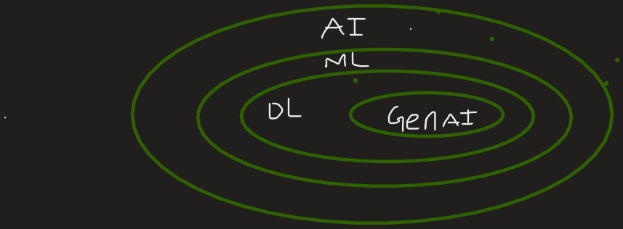
Fig: Techniques of Artificial Intelligence till now

Impacted Areas of Gen Ai:
- Content Creation
- Education
- Software Development
- Customer Support

Is GenAI Successful?
Let's ask ourselves a few questions.
- Does it solve real world problems? - It solves the real world problems like weather predictions, identifying issues in
- Is it useful on a daily basis? - Wea re using it in majority of situations in our day-to-day life
- Is it impacting the World economics? - Yes
- Is it creating new jobs? - Yes
- Is it accessible ? - Yes

GenAi can be simplified with the help of Foundation Models

Foundation Models:
- A type of AI model that need to be trained with huge amount of data literally the data present in the internet, need huge amount of GPUs, therefore increase the cost of infrastructure.
- This is a generalised model that can be used along with any other model
Ex: Large Language Models(LLMs), Large Multi-Modal Models (LMMs)

GenAI can be divided in to 2 models:
- User-perspective Models
- Builder-perspective Models

User-Perspective Model - Build another model using the existing Foundation Models
Builder-perspective Model - Build the model that is Foundation to other Models

Examples of User-perspective Models - Prompt Engineering, RAG, Ai Agents, Vector Databases

Examples of Builder-perspective Models - RLHF (Reinforcement Learning and Human Feedback), Pre-Training, Quantisation

Fine-Tuning - Combination of both User-perspective and Builder-perspective Models

Modules needed to build the Builder-perspective / Foundation Models:
- Transformer Architecture
- Types of Transformers:
a. Encoder only (BERT)
b. Decoder only (GPT)
c. Encoder and Decoder bases (T5)
- Pre-Training
a. Training Objectives
b. Tokenization Strategies
c. Training Strategies
d. Handling challenges
- Optimization
a. Training optimization
b. Model compression
c. Optimizing inference
- Fine-Tuning
a. Task Specific Tuning
b. Instruction Training
c. Continual Training
d. RLHF
e. PEFT
- Evaluation
- Deployment

Modules needed to build the User-Perspective Models:
- Building Basic LLM Apps
a. Open-source VS closed-source LLMs
b. Using LLM APIs
c. Hugging face - Repository for Models
d. Ollama
- Prompt Engineering
- RAG
- Fine-Tuning
- Agents - LLM with an external tool
- LLM Ops
- Miscellaneous - LMMs



Fig: Jobs scope for Builder-Perspective and User-perspective

